MSWORD

Q.1) What is Ms word?
Ans:- Ms word is an application software where we can do graphic work as well as text editing work.

Q.2) How can you start ms word?
Ans:- First of all click on start button and choose run option then a dialog box will appear on the screen write WINWORD and press enter button.

Q.3) What are the difference between word processor and type writer?
Ans:- 1) We can change the font style in word processor where as we can’t change the font style in type writer.
2) We can change the font colour in word processor where as we can’t change the font colour in type writer.
3) We can change the font size in word processor where as we can’t change the font size in type writer.
4) We can correct spelling and grammar mistake in word processor where as we can’t correct spelling and grammar mistake in type writer.

Q.4) What are the similarities between word processor and type writer?
Ans :- 1) Both give the output on a paper.
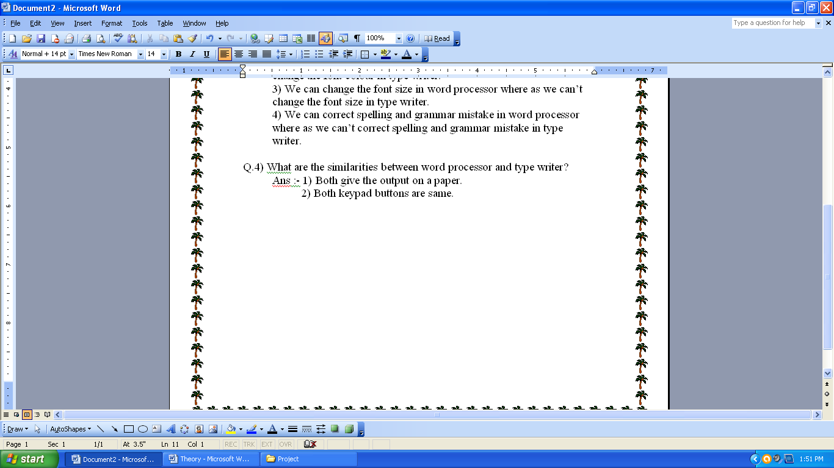
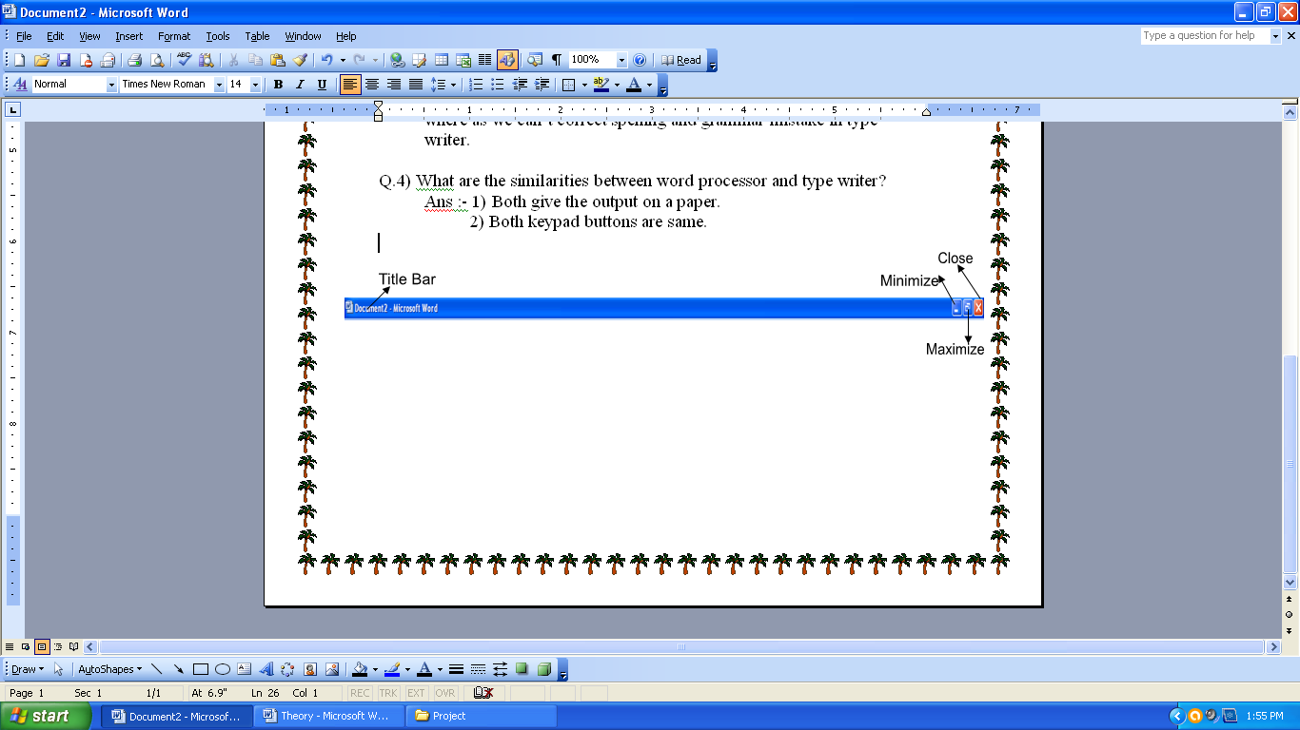
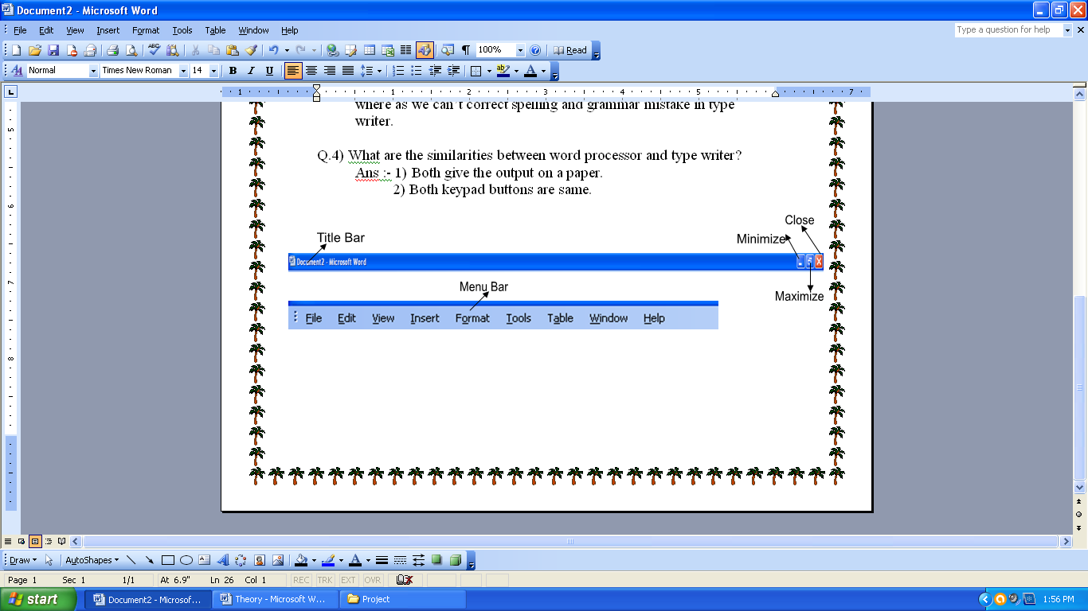
2) Both keypad buttons are same.
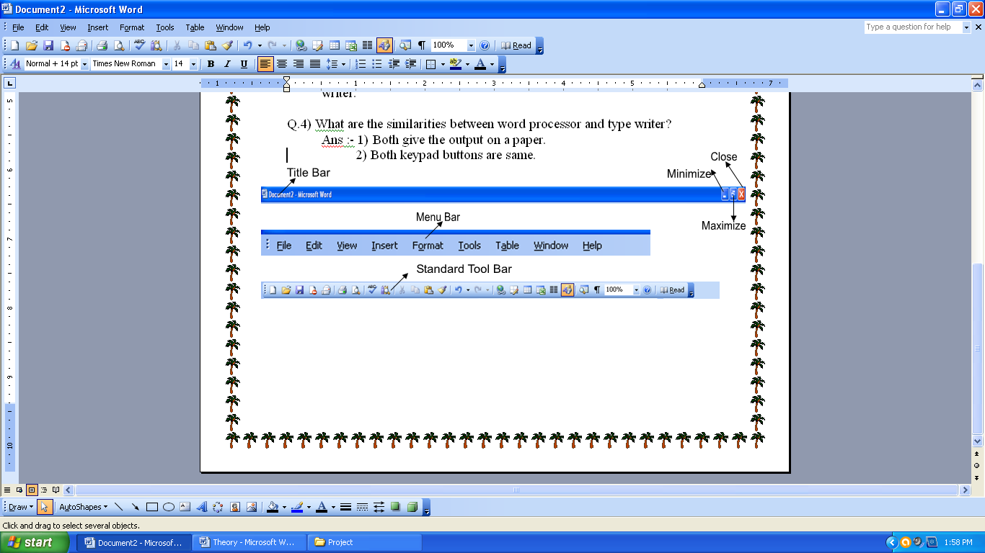
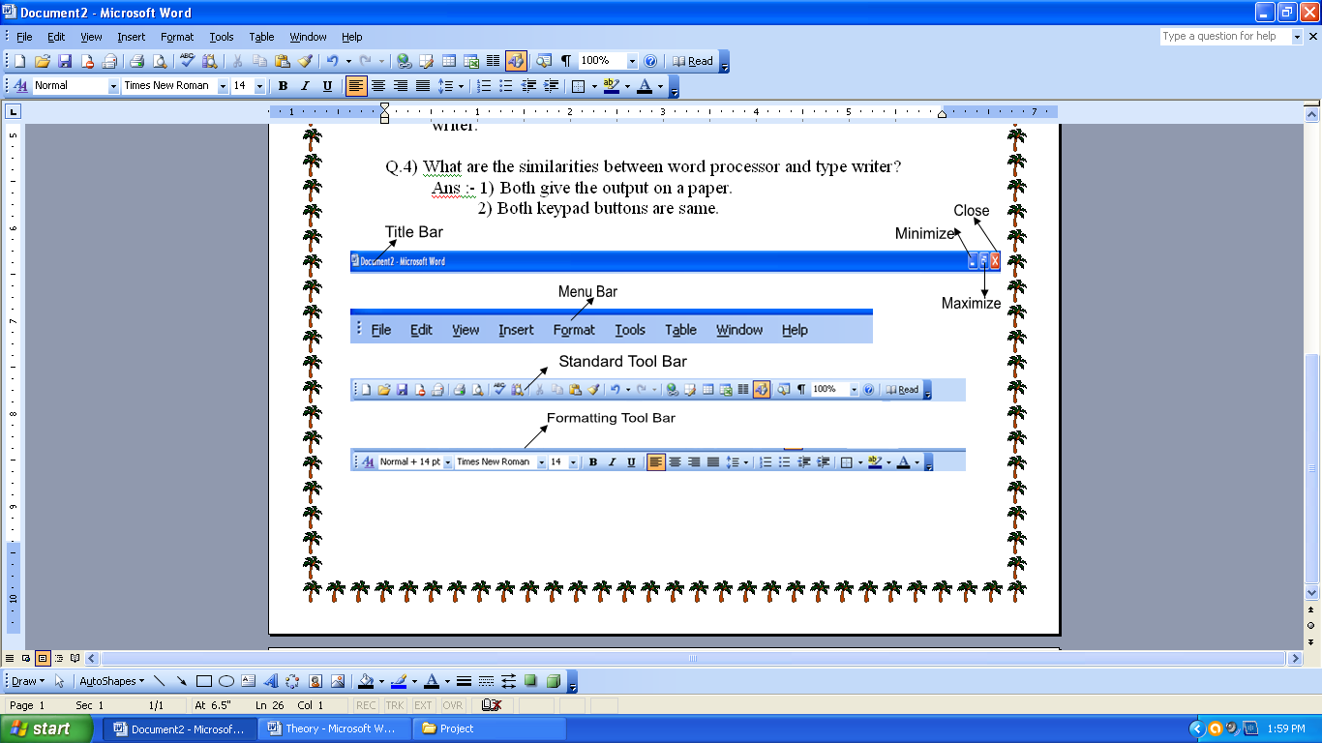

Q.5) How many menu are there in ms word?
Ans:- There are mainly 9 menu are in ms word.
1) File 2) Edit 3) View 4) Insert 5) Format
6) Tools 7) Table 8) Window 9) Help

Q.6) How many option are there in FILE menu?
Ans:- There are mainly 12 option are in file menu.
1) New:- it is used to take new page.

2) Open:- It is used to open any save file.

3) Close :- It is used to close Current open file.

4) Save :- It is used to save the file.

5) Save as :- It is used to save the file with a different name.

6) File Search :- It is used to search the save file.

7) Save as web page :- It is used to save the file on internet.

8) Page setup :- It is used to change the page style, page border, page margin.

9) Print Preview:- It is used to check the document before printing.

10) Print :- It is used to print the document.

11) Properties :- It is used to get the details of save file.

12) exit :- It is used to close ms word.

Q.2) How many option are there in edit menu?

Ans:- There are mainly 10 option are in edit menu.

1) Undo :- It is used to recover the deleted data.

- Redo :- It is used to delete the recover data.

- Cut :- It is used to cut the selected text or graphs.

- Copy :- It is used to copy the selected text or graphs.

- Paste :- It is used to paste the cut or copied data.

- Clear:- It is used to delete the format done by the user on text.

- Select all :- It is used to select all the data.

- Find :- It is used to find any word in the document.

- Replace :- It is used to replace the find word in the document.

- Go to :- It is used to go directly on any page, line, section, paragraph etc.

Q.1) How many option are there in view menu?
Ans:- There are mainly 13 options are in view menu.
1) Normal:- It is used to see the document in normal view.(With right side margined only.)

2) Web layout:- It is used to see the document in full page. (without any margined)

3) Print layout:- It is used to see the document with four side margined.(Up, Down, Left, Right)

4) Reading Layout:- It is used to get the document like a book for reading.

5) Outline:- It is used to get a point on every paragraph.

6) Toolbar:- It is used to show or hide the toolbar from the screen of ms word.

7) Ruler:- It is also used to show or hide the ruler/margin from the screen of ms word.

8) Document map / Thumbnails :- It is used to show a small page in the right side of the document.

9) Header & Footer :- It is used to write some notes on the header area and footer area.

10) Foot note : - It is used to write some notes on footer area only.

11) Zoom :- It is used to get the page zoom.
Maximum – 500% , Minimum – 10% , Normal- 100%

12) Markup:- It is used to mark the document with selected color.

13) Full screen :- It is used to get the document in full screen view.

Q.) How many options are there in insert menu?
Ans:- There are mainly 11 option are in insert menu.
1) Break:- It is used to break the page in two parts.

2) Page Number:- It is used to insert the page number on the page in different format

3) Date & Time:- It is used to insert Date & Time in different format on the page.

) Symbol:- It is used to insert special character symbol.

5) Comment:- It is used to insert comment on any save file.

6) Picture:- It is used to insert picture from clip art, from file, Word art, Scanner or camera etc.

7) Diagram:- It is used to insert diagram.

8) Text box:- it is used to insert rectangle with cursor.

9) File:- It is used to insert save file on the current file.

10) Object :- It is used to open any software with object option.

11) Hyperlink:- It is used to link two or more file.

Q.)How many options are there in format menu?
Ans:- There are mainly 10 option are in format menu.
1) Font:- It is used to change the font color, font style, font size, change underline, underline style, super script, sub scripts etc.

2) Paragraph :- It is used to get the gaping between two line, change the paragraph style etc.

3) Bullets & Numbering :- It is used to insert bullets & number on the page.

4) Border & Shading :- It is used to insert text border and page border on the page.

5) Column :- It is used to divide the page in column wise. (Max- 12 , Min – 1 )

6) Drop Cap :- It is used to change the size of the first character of the documents.

7) Text Direction :- It is used to change the text direction of the text in three ways.
a) Left to right b) Up to down c) down to up

8) Change Case :- It is used to change the sentences in to five cases.
a) Sentence case b) lower case c) UPPER CASE
d) Title Case e) tOGGLE cASE

9) Tab :- It is also used to give space but by default it can give 5 character space.

10) Background :- It is used to change the background color, insert printed water mark etc.

Q.)How many options are there in Tools Menu?
Ans:- There are mainly 6 options are in tools menu.
1) Spelling & Grammar: - It is used to correct spelling & grammar mistake.

2) Research :- it is used to get Theasure of any word.

3) Language – It is used to set the language as you need.

4) Word Count:- It is used to count the word, Line, Paragraph etc.

5) Protect document :- It is used to protect the document with a password.

6) Macro :- It is used to find out the shortcut keys in ms word.

Q.)How many options are there in Table menu?
Ans:- There are mainly 10 options are in table menu.
1) Draw table :- It is used to draw table, change line color, Fill color, erase lines, change line thickness etc.

2) Insert :- It is used to insert table in row & column format.

3) Delete :- It is used to delete table, Row, Column, Cell etc.

4) Select :- It is used to select whole table, row, column, cell etc

5) Merge cell:- It is used to merge two or more cells.

6) Split cells:- It is used to split the cells.

7) Split table :- It is used to split the table.

8) Autofit :- It is used to automatic fit the document in the page.

9) Formula:- It is used to insert the formula in the cell.

10) Hide gridlines :- It is used to hide the gridlines on the page.

